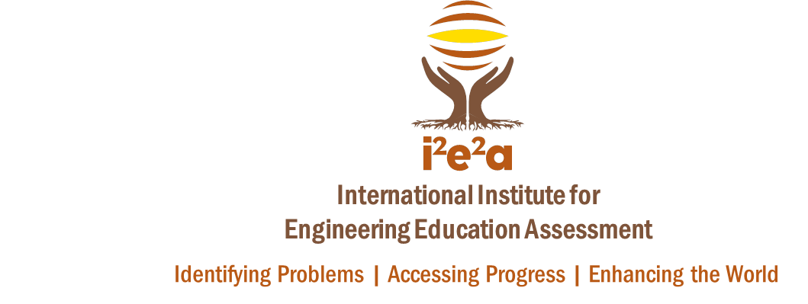
i2e2a.org
121st ASEE Conference & Exposition
June 15-18th, 2014
Indianapolis, IN

i²e²a Group Presentations, Posters, and Workshops
_____________________________________________________________________________________________________________________________________
Sunday, June 15
9:00 am-12:00 pm, Room 105
Jeremi London et al. “What is the Role of MOOCs in Engineering Education?”
1:00-4:00 pm, Room 111
Mary Pilotte, Monica Cox, et al. “Convincing the Non-believers: Selling Engineering Education Experiences on the Job Market”
_________________________________________________________________________________________
Monday, June 16
7:00-8:30 am, Room 116
Tasha Zephirin, Catherine Berdanier, Monica Cox, et al. “Snapshot of an Interdisciplinary Graduate Engineering Education Experience”
Nikitha Sambamurthy, Monica Cox, et al. “Preliminary Analyses of Survey and Student Outcome Data Using the Global Real-Time Tool for Teaching Enhancement (G-RATE)
7:00-8:30 am, Room 210
Tasha Zephirin, et al. “Can an Engineering Summer Bridge Program Effectively Transition Underrepresented Minority Students Leading to Increased Student Success?”
7:00-8:30 am, Room 211
Special Session Robin Adams, Monica Cox, et al. “GEECS as an Avenue for Networking, Collaborating, and Mentoring”
12:30-2:00 pm, Room 207
Benjamin Ahn, Monica Cox, et al. “Lessons Learned: Teaching Engineering Leadership in an Undergraduate Class Using Case Studies”
2:15-3:45 pm, Room 123
Monica Cox, Joyce Main, et al. “Women of Color Engineering Faculty: An Examination of the Experiences and the Numbers”
(Monday, June 16, cont.)
2:15-3:45 pm, Room 123
Monica Cox, Nikitha Sambamurthy, Catherine Berdanier, et al. “Transformation of Faculty Dissemination Practices via Social Media
_________________________________________________________________________________________
Tuesday, June 17
8:45-10:15 am, Room 112
Catherine Berdanier, Jeremi London, Benjamin Ahn, Monica Cox, et al. “Survey Analysis of Engineering Graduate Students’ Perceptions of the Skills Necessary for Career Success in Industry and Academia”
JD McClurkin, Velvet Fitzpatrick, Catherine Berdanier, Monica Cox, Cyndi Lynch “Development of Industry Modules for Engineers Pursuing Advanced Degrees”
Jiabin Zhu, Qunqun Liu, Monica Cox, “Applying Self-authorship Theory among Chinese Engineering Doctoral Students in U.S. Institutions”
12:30-2:30 Exhibit Hall A B C
First Year Programs Poster Session Monica Cox, et al. “Competing with ‘Real Classes’: The Value of Performing Ensemble Experiences for Non-Music Majors”
2:15-3:45, Room 112
Robin Adams, Catherine Berdanier, et al. “A Community of Practice Approach to Becoming an Engineering Education Research Professional”

